Mental health support and resources
Updated June 2026

Mental health support and resources across Staffordshire and Stoke-on-Trent
Crisis mental health access via NHS111: Anyone across Staffordshire and Stoke-on-Trent can get urgent mental health support, 24/7, by calling 111 and selecting the mental health option. If you’re deaf or have hearing loss, please use the following link to be connected to local crisis service – NHS 111 – SignVideo. If you aren’t able to make the call yourself, then anyone can call on your behalf – for example a friend, carer, loved one or even your GP. You can also access NHS 111 online via 111.nhs.uk.
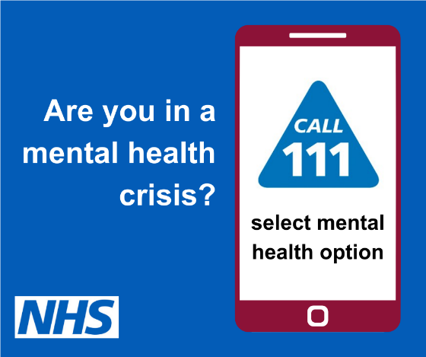

24/7 mental health text support: Anyone across Staffordshire and Stoke-on-Trent can access 24/7 mental health support by text with free text services across the area. Individuals can text the following numbers to receive support for their mental health at any time of the day or night. For South Staffordshire – 07507 330605. For North Staffordshire and Stoke-on-Trent – 07312 263117.
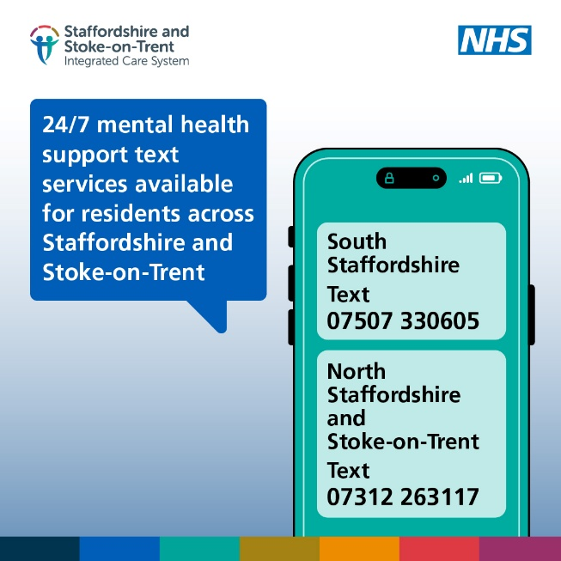

NHS Talking Therapies Staffordshire and Stoke-on-Trent: Free and confidential talking therapy. Call 0300 303 0923 or visit the website for more information.
Stay Well Staffordshire: Mental health support for children and young people in Staffordshire. See the website for more details or call 01782 418518 Option 2 Newcastle & Staffs Moorlands, or Option 3 Cannock, Stafford, Tamworth, East Staffs, Lichfield & South Staffs.
Combined Wellbeing Portal: Run by North Staffordshire Combined Healthcare NHS Trust, this online resource offers mental health information and signposting.
Changes: Peer recovery and support for mental health and wellbeing. Visit the website for more information, or contact 01782 411433, email: contact@changes.org.uk
Amparo Staffordshire and Stoke-on-Trent: Amparo offers support for anyone affected by suicide in Staffordshire and Stoke-on-Trent. Call 0330 088 9255 or visit the website.
Andy’s Man Club: Peer-to-peer support groups for men’s mental health and suicide prevention. Visit the website for more information about local groups or email info@andysmanclub.co.uk
Men Unite: Online peer support group for men. Visit the website for more information.
The Dove Service: Providing bereavement and loss counselling since 1984, the charity supports children and adults who are experiencing issues relating to bereavement, loss or life-changing illness throughout Staffordshire, Cheshire and Wirral. Call 01782 914455 or visit the website.
Lotus Service North Staffordshire: The Lotus Service provides support across North Staffordshire and Stoke-on-Trent for those who are looking for help with their mental health which has been significantly affected by: miscarriage, ectopic pregnancy, termination of pregnancy, stillbirth or neonatal death, extreme fear of childbirth (tokophobia), experiencing pregnancy and/or birth as traumatic or difficult, or neonatal admission or experience of separation from your baby(ies). Visit the website for more information.
South Staffordshire Perinatal and Maternal Mental Health Team: South Staffordshire Perinatal and Maternal Mental Health Team provides specialist assessment and support for people across South Staffordshire, providing both support to those people experiencing mental health difficulties and those at risk of developing mental health difficulties in pregnancy up until baby is 24 months old. The service supports people experiencing moderate to severe mental health problems. Visit the website for more information, and the service states ‘Please talk to your Midwife, GP, Health Visitor, or other healthcare professional for a referral to our service’.
YESS (Your Emotional Support Service): Mental health and wellbeing centre based in Uttoxeter, supporting adults and children across Staffordshire. Visit the website for more information.
BeeFree: Support for mental health and movement. Visit the website for more information.
The NHS advises people to call 999 if there is a serious risk to life.

National resources include:
Samaritans: Offers a free, confidential listening service at 116 123, 24 hours a day.
PAPYRUS: Prevention of young suicide. For confidential suicide prevention advice, contact 0800 068 4141.
Mind: Call 0300 300 5468 or visit website.
Young Minds: Helpline offering information, advice and support to parents and carers who are concerned about their child or young person’s mental health. 0808 802 5544, weekdays 9.30am – 4pm.
The Silver Line Helpline: Offers a free, 24-hour telephone service for people aged 55 or over at 0800 4 70 80 90
OMEGA: Ending Isolation | Ending Loneliness: 01743 245088. Omega is a registered charity dedicated to reducing social isolation and loneliness. They offer a service called ‘Chatterbox’, a free telephone befriending service and Letterbox, a free penpal befriending service.
Childline: Free confidential support for anyone under 19. Contact 0800 1111 or visit the website for more information.
Survivors of Bereavement by Suicide (SOBS): National organisation offering peer-led support to anyone impacted by suicide loss. National Support Line – 0300 111 5065, email.support@uksobs.org or visit the website.
Cruse Bereavement Support: Provides expert bereavement and grief support. Helpline – 0808 808 1677 or visit the website.
Child Bereavement UK: Offers free, UK-wide, accessible online grief support to children and young people (up to 25) who are bereaved or facing the death of someone important, and the parents and carers of babies and children who are dying or have died. The charity also offers guidance and resources for those supporting bereaved families, whether a parent, family member or friend, as well as tailored advice, training and education programmes for professionals. Helpline – 0800 02 888 40 or visit the website.

